Amyotrophic Lateral Sclerosis (ALS): Care & Ventilation
Name of Author:
Institution:
Date:

Background: Causes, Manifestations and Physiology
Amyotrophic lateral sclerosis (ALS), a motor neuron illness, refers to a progressive condition whereby an individual loses nerves that control movement (Radunovic et al., 2017). Ultimately, the patient suffers a loss in muscle control. The disease is also called Lou Gehrig's disease, a name derived from a baseball player who was a pioneer patient diagnosed with it. Today, the cause of ALS is unknown but specific risks that accelerate it include age, environmental toxin exposure, smoking, age, and military service (Mayo Clinic, 2021). Nonetheless, some evidence shows that a fraction of cases are due to hereditary conditions (Radunovic et al., 2017). This disease mainly manifests in individuals aged between 40 years and 70 years, with an estimated 6,000 people diagnosed annually in the US (Hanlon, 2017). Data from the ALS Association shows that patients live for about three years in the post-diagnosis period, with a fifth surviving up to five years and a tenth living up to a decade (Hanlon, 2017).
As already identified, ALS disease causes impairment in muscles and can be manifested in different ways from individual to individual. Some of the most typical signs and symptoms include, among others, difficulties in walking, weaknesses in legs and hands, tripping and falling, slurred speech, difficulty in swallowing food as well as muscle cramps, and twitching (Mayo Clinic, 2021). Once the illness sets in, one's behavioral and cognitive changes occur with early impairments in legs and hands, and then muscle weakness spreads to the rest of the body parts. However, overall, ALS is not commonly associated with pain. Unfortunately, scholarly evidence points to a lack of a cure with some treatments administered to manage symptoms (Radunovic et al., 2017). ALS is a fatal disease that requires adequate care and intervention to increase survival rates among the affected populations. Figure 1 below shows the manifestation of ASL through hyperintensity on an MRI scan.
Figure 1: ASL Manifestation on MRI Scan; patient vs control
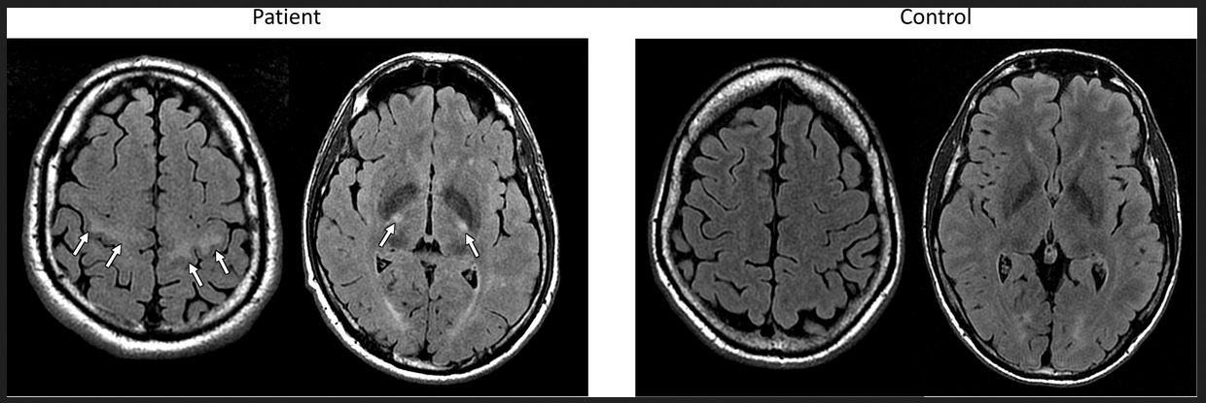
Source: Mazon et al., (2018)
Respiratory Insufficiencies & Ventilation Care
Patients with ASL are often associated with respiratory insufficiencies since the breathing system requires energy and muscular coordination. The most typical cause of death among ASL patients is neuromuscular respiratory failure, and therefore it is essential to have proper monitoring and care (Sancho et al., 2011). The respiratory muscles' weaknesses expose persons with ASL to supine dyspnea, fatigue, dyspnea with mild exertion, depression, insomnia, and weight loss, among other conditions (Gilani et al., 2021). While no standard protocols exist to identify early respiratory failure, tests such as maximal inspiratory pressure (MPI) can effectively determine the sensitivity of the system (Gilani et al., 2021). Vital Capacity tests can also measure diaphragmatic weaknesses such as VC less than a third of the predicted value may signify respiratory failure (Gilani et al., 2021).
In light of the vulnerabilities brought about by respiratory failures, mechanical ventilation is ideal involving machines supporting a patient's breathing, as shown in figure 2 below. Usually, mechanical ventilation is done invasively (use of tracheostomy) or non-invasively (without tracheostomy where a mask is connected to a portable ventilator) (Radunovic et al., 2017). On one hand, the ALS practice parameter set by the American Academic Neurology recommends that non-invasive ventilation (NIV) be utilized to treat respiratory insufficiencies to lengthen patients' survival. NIV is also considered less risky and offers more benefits to the patients.
Figure 2: Example of Mechanical Ventilation to ASL patient

Further on, in NIV, the use of bi-levels like Air Curve ST-A by ResMed is crucial in the early stages, while life support devices such as Astral ventilator are essential in the progressive stage of the diseases (Hanlon, 2017). It is vital to use equipped devices such as ventilators with suite alarms and internal batteries to monitor and offer patient care stability. Scholarly evidence has shown that the use of mechanical ventilation in ASL management would elongate the patient's survival and ensure better quality of life (Radunovic et al., 2017). In a sample of 41 participants, the researchers found that the use of the NIV technique offered 48 days longer in survival, which marked 219 days for NIV in comparison to 171 days in standard care. In a separate study, O'Brien et al. (2019) found that while NIV extends survival and quality of life for ASL patients, the positive outcomes depend on how best ventilation and adherence are optimized. Therefore, the ventilation approaches need to suit the varying needs of patients, and adjustments are needed to make care effective.
On the other hand, a section of research outlines that the use of mechanically assisted invasive ventilation (MAIV) is an ideal approach to prolong the life of ASL patients. However, Pinto (2013) provides that the use of MAIV comes with life-threatening complications. A more in-depth evaluation is required to ascertain its effectiveness in the care of patients with ASL. Some of the risks associated with MAIV include alveolar damage, injury to the airways, ventilator-associated pneumonia, and tracheobronchitis (Brochard, 2003; Pinto, 2013). These risks make mechanically assisted invasive ventilation unpopular in the care and treatment of ALS. Compared to MAIV, use of NIV offers more effectiveness in compensating for diaphragm weakness, alleviating hypercapnic symptoms, and enhancing general conditions of wellness (Dorst and Ludolph, 2019).
Conclusion
Amyotrophic lateral sclerosis (ALS) is a degenerative disease that ultimately impairs the functioning of bodily muscles and nerves. There is no known cause of the disease apart from some indications to genetic factors. The disease offers various symptoms ranging from limb impairments, difficulty in swallowing, slurred speech, and muscle cramps. While there are no known treatments for the disease, the use of machine-assisted ventilation offers better quality of life and longevity in a patient's survival. This paper has reviewed both the invasive and noninvasive approaches to ventilation care and ascertained that noninvasive ventilation is more effective and less risky offering better health outcomes for the patient. However, it is vital to advance care in ways that reflect the needs of the patients.
.

References
Brochard, L. (2003). Mechanical ventilation: invasive versus noninvasive. European Respiratory Journal, 22, 31-37 DOI: 10.1183/09031936.03.00050403
Dorst, J., & Ludolph, A. C. (2019). Non-invasive ventilation in amyotrophic lateral sclerosis. Therapeutic advances in neurological disorders, 12, 1756286419857040. Doi: 10.1177/1756286419857040
Gilani, A., Hinn, A., & Jacobson, P. (2021). Management of Respiratory Failure in ALS. Palliative care Network of Wisconsin. Retrieved on 21 February 2021 from https://www.mypcnow.org/fast-fact/management-of-respiratory-failure-in-als/
Hanlon, P. (2019). ALS Care and Ventilation. RT Magazine. Retrieved on 21 February 2021 from https://rtmagazine.com/department-management/clinical/als-care-ventilation/
Mayo Clinic (2021). Amyotrophic lateral sclerosis (ALS). Retrieved on 21 February 2021 from https://www.mayoclinic.org/diseases-conditions/amyotrophic-lateral-sclerosis/symptoms-causes/syc-20354022
Mazón M, Vázquez Costa JF, Ten-Esteve A and Martí-Bonmatí, L. (2018). Imaging Biomarkers for the Diagnosis and Prognosis of Neurodegenerative Diseases. The Example of Amyotrophic Lateral Sclerosis. Front. Neurosci. 12,784-98. Doi: 10.3389/fnins.2018.00784
O’Brien, D., Stavroulakis, T., Baxter, S., Norman, P., Bianchi, S., Elliott, M., & McDermott, C. (2019). The optimization of non-invasive ventilation in amyotrophic lateral sclerosis: A systematic review. European Respiratory Journal, 1900261. Doi:10.1183/13993003.00261-2019
Pinto, A. C. (2013). Mechanically Assisted Invasive Ventilation for ALS patients: Is it the Ultimate Strategy to Improve Survival? Revista Portuguesa de Pneumologia, 19(4), 184–185. doi:10.1016/j.rppneu.2013.06.003
Radunovic, A., Annane, D., Rafiq, K., Brassington, R., and Mustfa N. (2017). Mechanical ventilation for amyotrophic lateral sclerosis/motor neuron disease. Cochrane Database of Systematic Reviews, Issue 10. Art. No.: CD004427. DOI: 10.1002/14651858.CD004427.pub4.
Sancho, J., Servera, E., Díaz, L., et al. (2011). Home tracheotomy mechanical ventilation in patients with amyotrophic lateral sclerosis: causes, complications and 1-year survival. Thorax, 66, 948-952.

